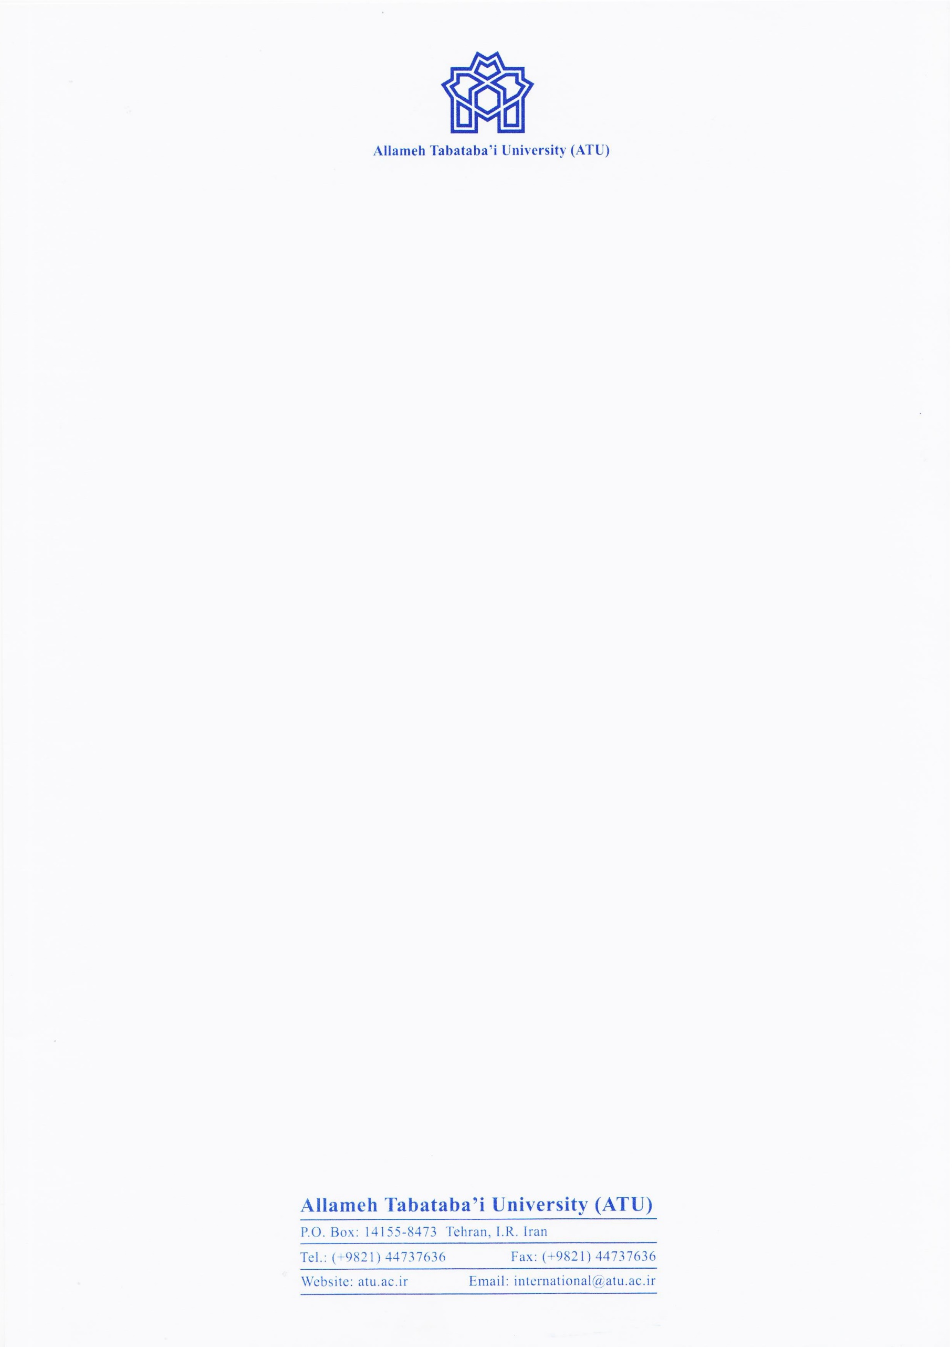

Date:

Ref. No.: 2021-G

Dear Sir/Madam,

This is to certify that Mr/Ms. ........., is a .......... student in ................ at Allameh Tabataba’i University (ATU), with Student No. ................ and he/she intends to undergo a virtual exchange stay at Justus Liebig University Giessen.

Faithfully yours,

Dr. Mandana Tishehyar,

Director of International Academic Cooperation